Type-C To HDMI 4K Video Adapter
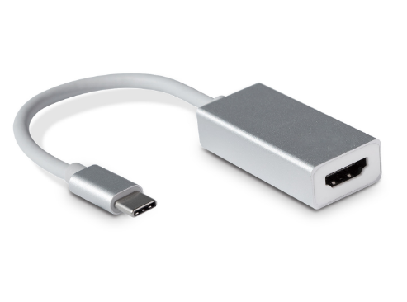
C-TC-HDMI

Descrption:
Convert Your Existing Type-C Port On Your MacBookTM, WindowsTM and compatible Type-C devices to output HDMI displays and projectors - Up to 4K resolution
Utilize your existing Type-C port on your notebook, desktop or other compatible device and convert the port to a compatible, legacy HDMI display adapter found on monitors, displays, projectors and other types of legacy display devices.

Displays up to 4K resolutions on compatible displays. Ideal for all computers and compatible devices including MacBookTM, WindowsTM and other devices using the next-generation Type-C interface.

FEATURES:
- USB-C Input:Support VESA USB Type-C DisplayPort Alt Mode
- Video output:DP female connector, up to 4K@30Hz resolution
- PC with USB-C interface supporting VESA USB Type-C DisplayPort Alt Mode
- Supported Operating System Windows® 10 Mac OS® Chrome OS™
- Certifications: CE,FCC,RoHs

Product Code:
- Part number: C-TC-HDMI
- Weight: 40g
- Size:47.2*22.8*12.3mm
- Barcode: 8400800036780
- 